Device Management Platform

API Guide for RuleEngine

# GetDeviceInfoByImei WS

**API request:**

To make a request you need to Imei variable.

http://localhost:8080/DMC/GetDeviceInfoByImei?pUser=c&pPwd=c&pImei=@imei

|  |  |
| --- | --- |
| Parameter Name | ***Description*** |
| pUser | ***pUser is like an authentication username parameter.*** |
| pPwd | ***pPwd is like an authentication password parameter.*** |
| pImei | **Triplet IMEI parameter** |

HTTP GET method is used to call the service.

Sample request:

<http://localhost:8080/DMC_CORE/GetDeviceInfoByImei?pUser=c&pPwd=c&pImei=866789049255491>

**API response:**

**success case:**

{

"insertDate": "May 25, 2021 12:16:56 PM",

"handset": {

"id": 19832,

"insertDate": "Oct 27, 2023 7:00:04 AM",

"handsetImei": []

},

"imeiVendorName": "XIAOMI",

"imeiModelName": "REDMI 6A",

"isPhone": false,

"omaSupport": false,

"tablet": false,

"smartphone": false

}

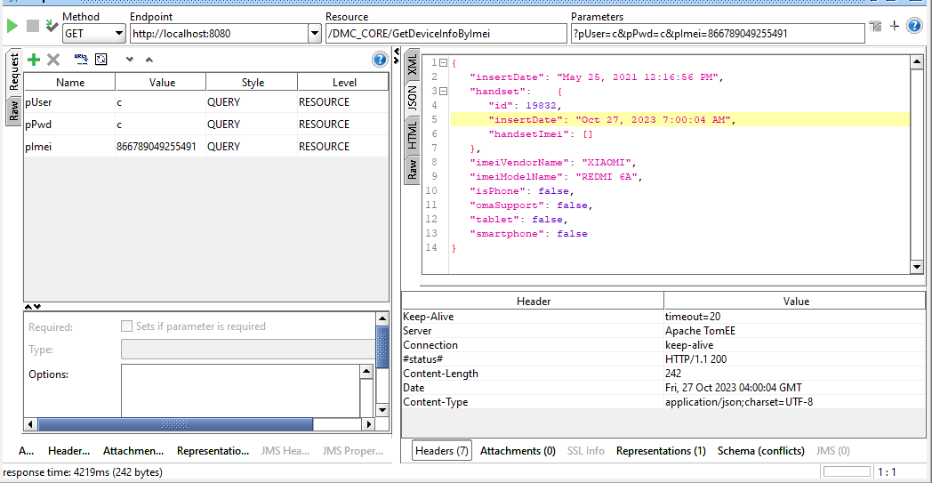

**failed case (Authentication related):**

{"status": "ERROR+Bad username"}

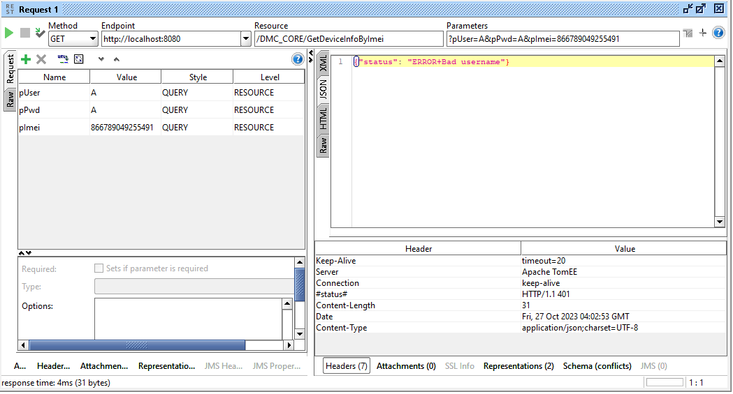

**failed case (No Device is found):**

null

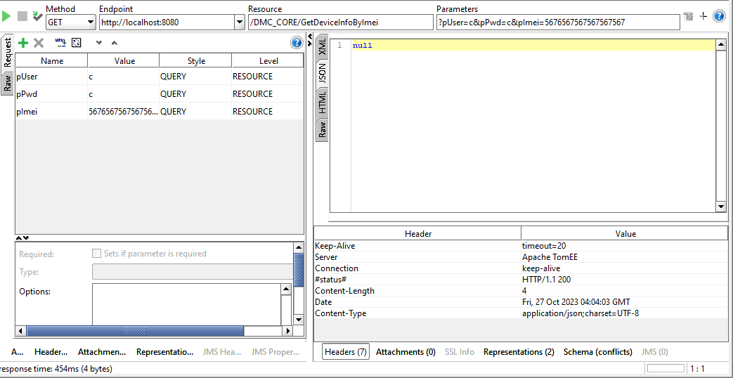

# ListDmcSettings WS

**API request:**

To make a request you need to Imei variable.

http://localhost:8080/DMC/ListDmcSettings?pUser=c&pPwd=c

|  |  |
| --- | --- |
| Parameter Name | ***Description*** |
| pUser | ***pUser is like an authentication username parameter.*** |
| pPwd | ***pPwd is like an authentication password parameter.*** |
| pImei | **Triplet IMEI parameter** |

HTTP GET method is used to call the service.

Sample request:

http://localhost:8080/DMC_CORE/ListDmcSettings?pUser=c&pPwd=c

**API response:**

**success case:**

[

{

"imsi": "219021",

"settingType": "BINARY",

"settingSmsApdu": "",

"settingSmsXml": "<WAP-PROVISIONINGDOC> <CHARACTERISTIC TYPE=\"BOOTSTRAP\"> <PARM NAME=\"NAME\" VALUE=\"Telemach postavke\"/> <\/CHARACTERISTIC> <CHARACTERISTIC TYPE=\"PXLOGICAL\"> <PARM NAME=\"PROXY-ID\" VALUE=\"PROXY1\"/> <PARM NAME=\"NAME\" VALUE=\"Telemach postavke APN\"/> <CHARACTERISTIC TYPE=\"PORT\"> <PARM NAME=\"PORTNBR\" VALUE=\"80\"/> <\/CHARACTERISTIC> <CHARACTERISTIC TYPE=\"PXPHYSICAL\"> <PARM NAME=\"PHYSICAL-PROXY-ID\" VALUE=\"PPROXY1\"/> <PARM NAME=\"PXADDR\" VALUE=\" \"/> <PARM NAME=\"PXADDRTYPE\" VALUE=\"IPV4\"/> <PARM NAME=\"TO-NAPID\" VALUE=\"NAP1\"/> <\/CHARACTERISTIC> <\/CHARACTERISTIC> <CHARACTERISTIC TYPE=\"PXLOGICAL\"> <PARM NAME=\"PROXY-ID\" VALUE=\"PROXY2\"/> <PARM NAME=\"NAME\" VALUE=\"Telemach postavke MMS\"/> <CHARACTERISTIC TYPE=\"PORT\"> <PARM NAME=\"PORTNBR\" VALUE=\"80\"/> <\/CHARACTERISTIC> <CHARACTERISTIC TYPE=\"PXPHYSICAL\"> <PARM NAME=\"PHYSICAL-PROXY-ID\" VALUE=\"PPROXY2\"/> <PARM NAME=\"PXADDR\" VALUE=\"86.32.5.243\"/> <PARM NAME=\"PXADDRTYPE\" VALUE=\"IPV4\"/> <PARM NAME=\"TO-NAPID\" VALUE=\"NAP2\"/> <\/CHARACTERISTIC> <\/CHARACTERISTIC> <CHARACTERISTIC TYPE=\"NAPDEF\"> <PARM NAME=\"NAPID\" VALUE=\"NAP1\"/> <PARM NAME=\"BEARER\" VALUE=\"GSM-GPRS\"/> <PARM NAME=\"NAME\" VALUE=\"Telemach postavke APN\"/> <PARM NAME=\"NAP-ADDRESS\" VALUE=\"internet\"/> <PARM NAME=\"NAP-ADDRTYPE\" VALUE=\"APN\"/> <\/CHARACTERISTIC> <CHARACTERISTIC TYPE=\"NAPDEF\"> <PARM NAME=\"NAPID\" VALUE=\"NAP2\"/> <PARM NAME=\"BEARER\" VALUE=\"GSM-GPRS\"/> <PARM NAME=\"NAME\" VALUE=\"Telemach postavke MMS\"/> <PARM NAME=\"NAP-ADDRESS\" VALUE=\"mms\"/> <PARM NAME=\"NAP-ADDRTYPE\" VALUE=\"APN\"/> <CHARACTERISTIC TYPE=\"NAPAUTHINFO\"> <PARM NAME=\"AUTHTYPE\" VALUE=\"PAP\"/> <PARM NAME=\"AUTHNAME\" VALUE=\" \"/> <PARM NAME=\"AUTHSECRET\" VALUE=\" \"/> <\/CHARACTERISTIC> <\/CHARACTERISTIC> <CHARACTERISTIC TYPE=\"APPLICATION\"> <PARM NAME=\"APPID\" VALUE=\"w2\"/> <PARM NAME=\"TO-PROXY\" VALUE=\"PROXY1\"/> <CHARACTERISTIC TYPE=\"RESOURCE\"> <PARM NAME=\"NAME\" VALUE=\"Telemach postavke\"/> <PARM NAME=\"URI\" VALUE=\"http://telemach.hr\"/> <PARM NAME=\"STARTPAGE\"/> <\/CHARACTERISTIC> <\/CHARACTERISTIC> <CHARACTERISTIC TYPE=\"APPLICATION\"> <PARM NAME=\"APPID\" VALUE=\"w4\"/> <PARM NAME=\"TO-PROXY\" VALUE=\"PROXY2\"/> <PARM NAME=\"ADDR\" VALUE=\"http://mms.telemach.hr\"/> <\/CHARACTERISTIC> <\/WAP-PROVISIONINGDOC> ",

"channelId": 0,

"sender": "Telemach"

},

{

"imsi": "219022",

"settingType": "BINARY",

"settingSmsApdu": "",

"settingSmsXml": "<WAP-PROVISIONINGDOC> <CHARACTERISTIC TYPE=\"BOOTSTRAP\"> <PARM NAME=\"NAME\" VALUE=\"Telemach\"/> <\/CHARACTERISTIC> <CHARACTERISTIC TYPE=\"PXLOGICAL\"> <PARM NAME=\"PROXY-ID\" VALUE=\"PROXY1\"/> <PARM NAME=\"NAME\" VALUE=\"Telemach Internet\"/> <CHARACTERISTIC TYPE=\"PORT\"> <PARM NAME=\"PORTNBR\" VALUE=\"\"/> <\/CHARACTERISTIC> <CHARACTERISTIC TYPE=\"PXPHYSICAL\"> <PARM NAME=\"PHYSICAL-PROXY-ID\" VALUE=\"PPROXY1\"/> <PARM NAME=\"PXADDR\" VALUE=\" \"/> <PARM NAME=\"PXADDRTYPE\" VALUE=\"IPV4\"/> <PARM NAME=\"TO-NAPID\" VALUE=\"NAP1\"/> <\/CHARACTERISTIC> <\/CHARACTERISTIC> <CHARACTERISTIC TYPE=\"NAPDEF\"> <PARM NAME=\"NAPID\" VALUE=\"NAP1\"/> <PARM NAME=\"BEARER\" VALUE=\"GSM-GPRS\"/> <PARM NAME=\"NAME\" VALUE=\"Telemach Internet\"/> <PARM NAME=\"NAP-ADDRESS\" VALUE=\"surf.telemach.hr\"/> <PARM NAME=\"NAP-ADDRTYPE\" VALUE=\"APN\"/> <\/CHARACTERISTIC> <CHARACTERISTIC TYPE=\"APPLICATION\"> <PARM NAME=\"APPID\" VALUE=\"w2\"/> <PARM NAME=\"TO-PROXY\" VALUE=\"PROXY1\"/> <CHARACTERISTIC TYPE=\"RESOURCE\"> <PARM NAME=\"NAME\" VALUE=\"Telemach\"/> <PARM NAME=\"URI\" VALUE=\"surf.telemach.hr\"/> <PARM NAME=\"STARTPAGE\"/> <\/CHARACTERISTIC> <\/CHARACTERISTIC> <\/WAP-PROVISIONINGDOC>",

"channelId": 0,

"sender": "Telemach Corp"

}

]

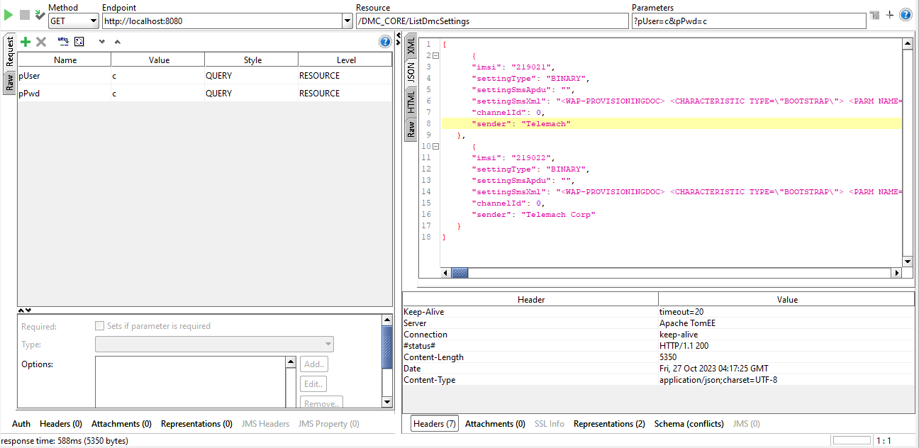

**failed case (Authentication related):**

{"status": "ERROR+Bad username"}

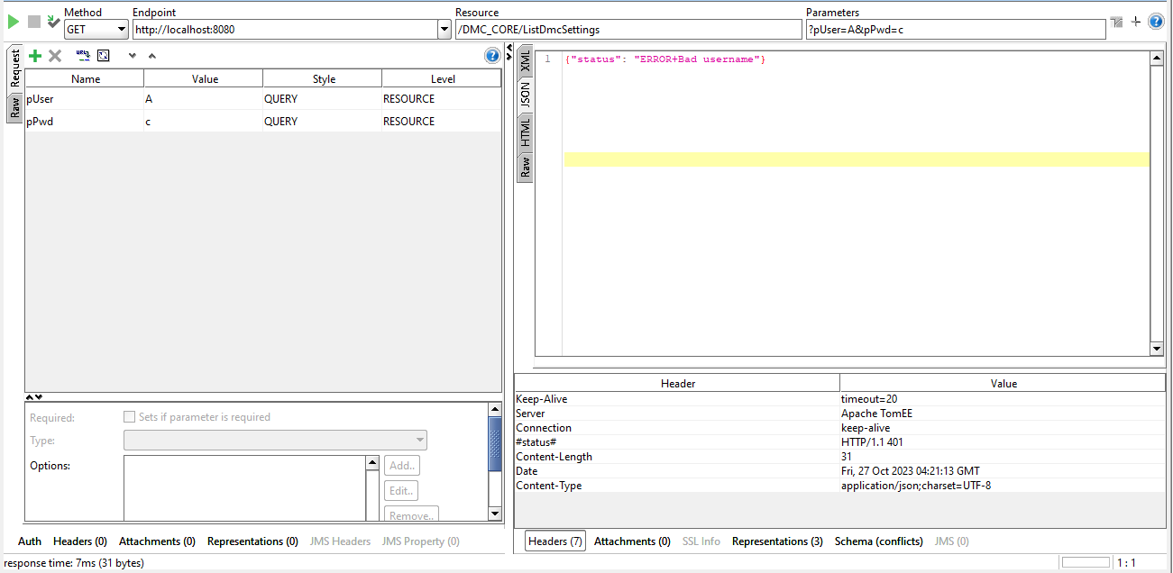

**Notes:**

**Explanations of responses**

|  |  |  |
| --- | --- | --- |
| ***Http Status Code*** | ***Type*** | ***Description of the case*** |
| **200** | **OK** | Standard response for successful HTTP requests |
| **401** | **Unauthorized** | When authentication is required and has failed |